

TESTS LOGS
Release 1.0

January 25, 2010
Firenze

Task representation
- Task atomico, non suddiviso in sottotask.
Esempio 1:
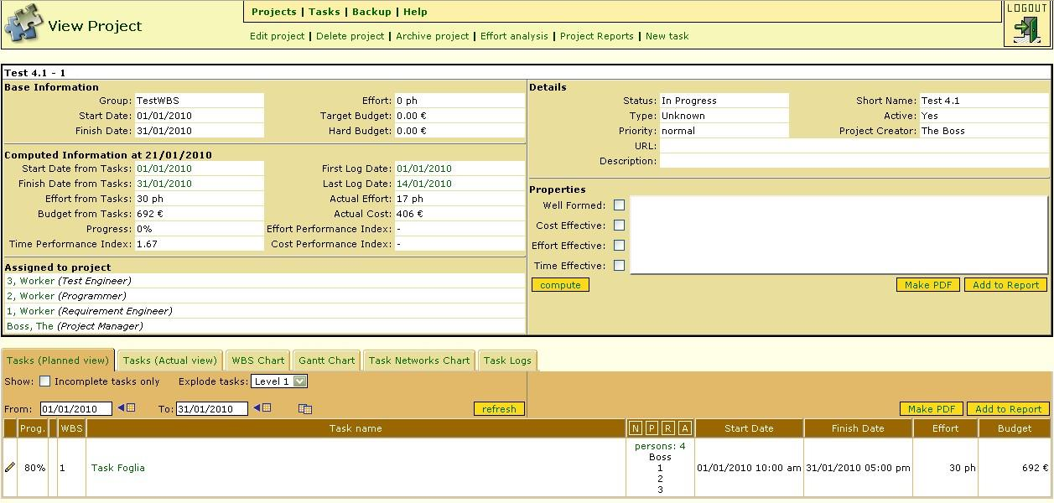
Figura 1: Input, planned view
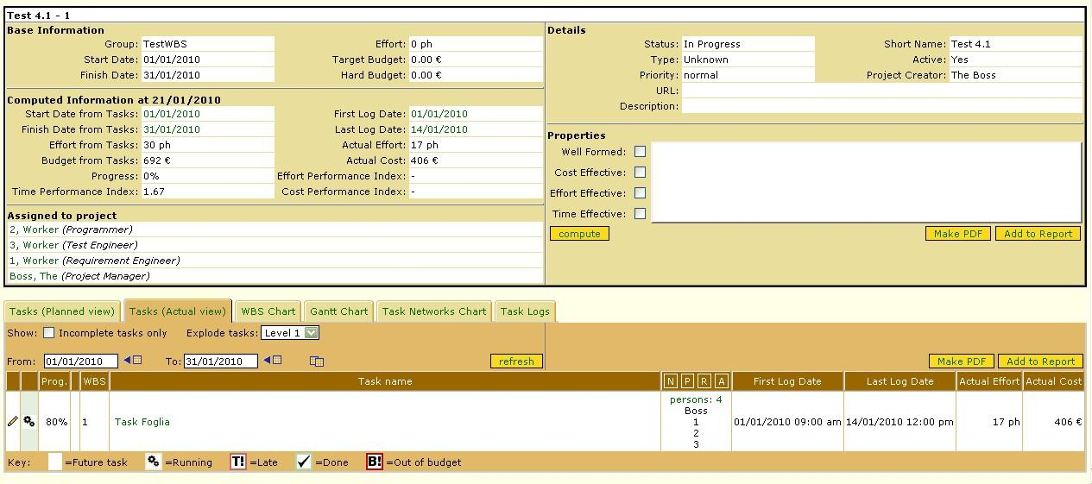
Figura 2: Input, actual view
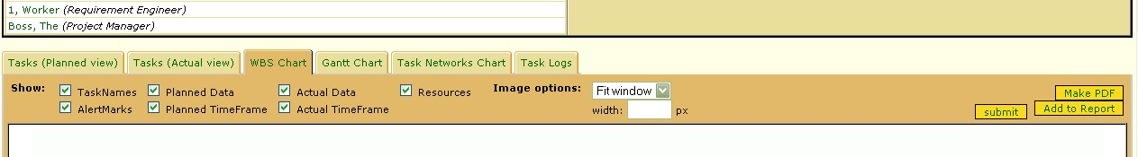
Figura 3: Environment

Figura 4: Output
Esempio 2:
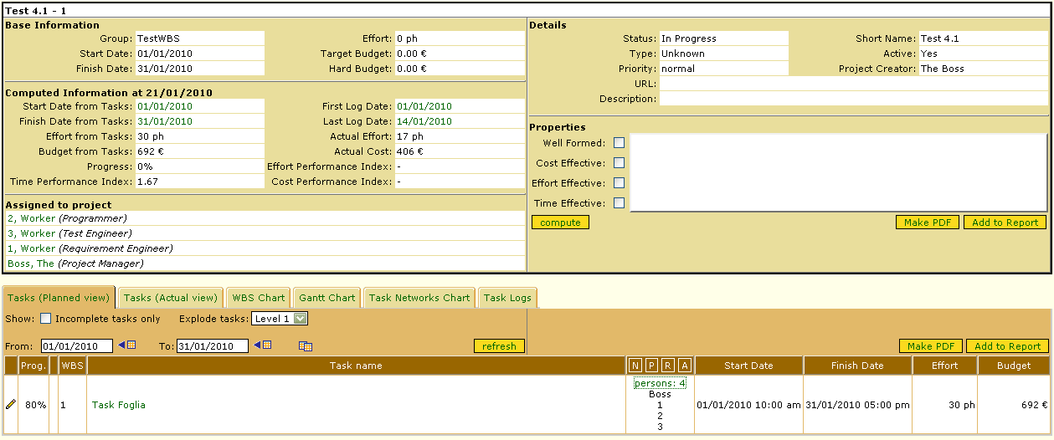
Figura 5: Input, planned view
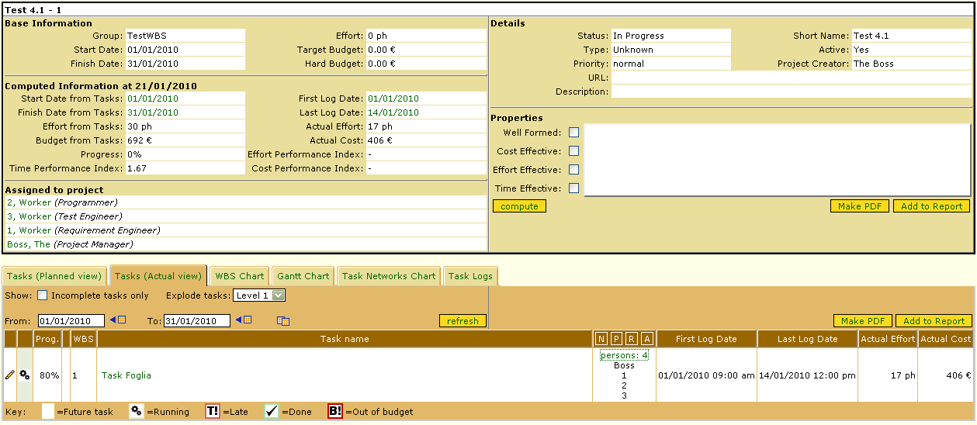
Figura 6: Input, actual view
Figura 7: Environment

Figura 8: Output
Esempio 3:
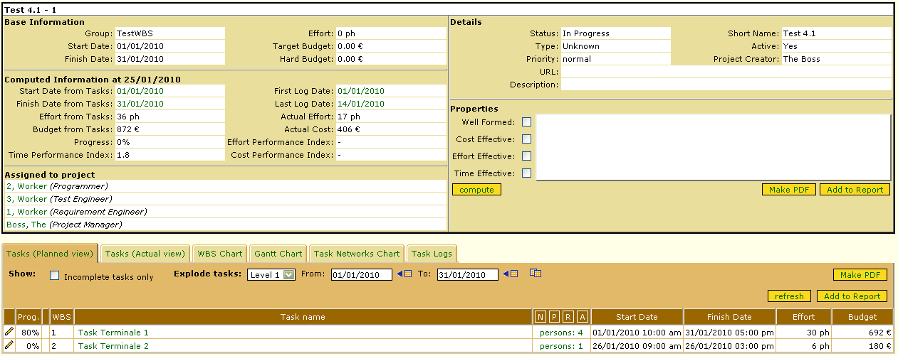
Figura 9: Input, planned view
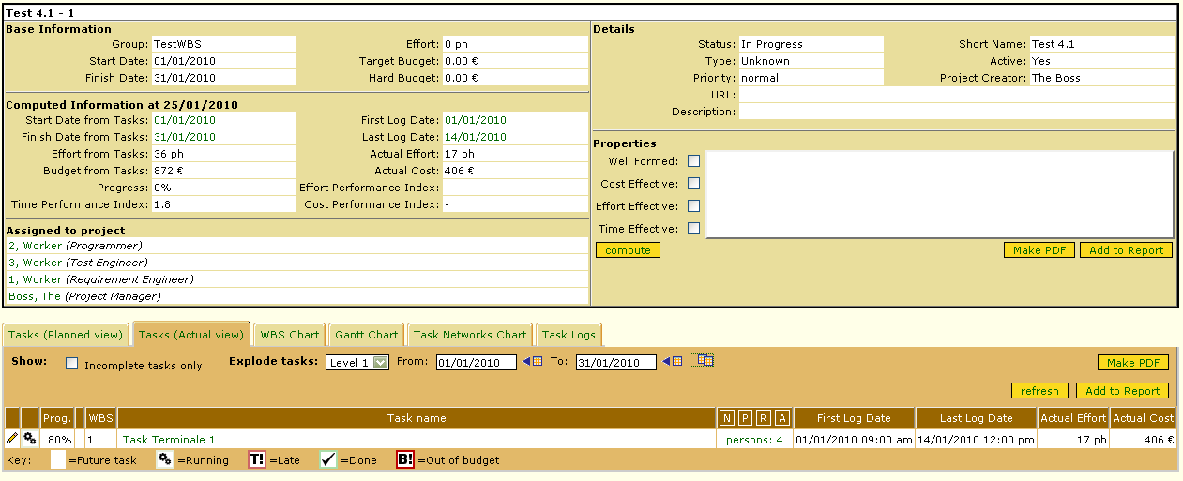
Figura 10: Input, actual view
Figura 11: Environment

Figura 12: Output

- Task composto, visualizzando i sottotask del livello successivo.
Esempio 1:
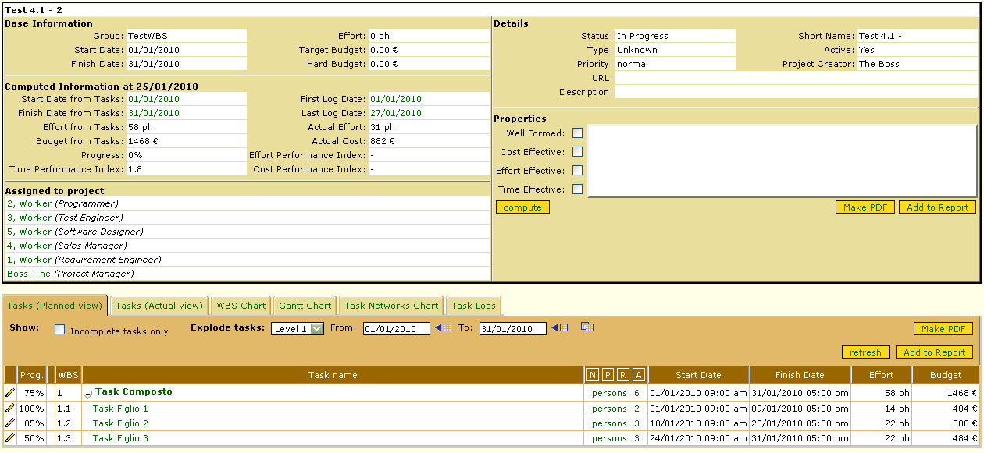
Figura 13: Input, planned view
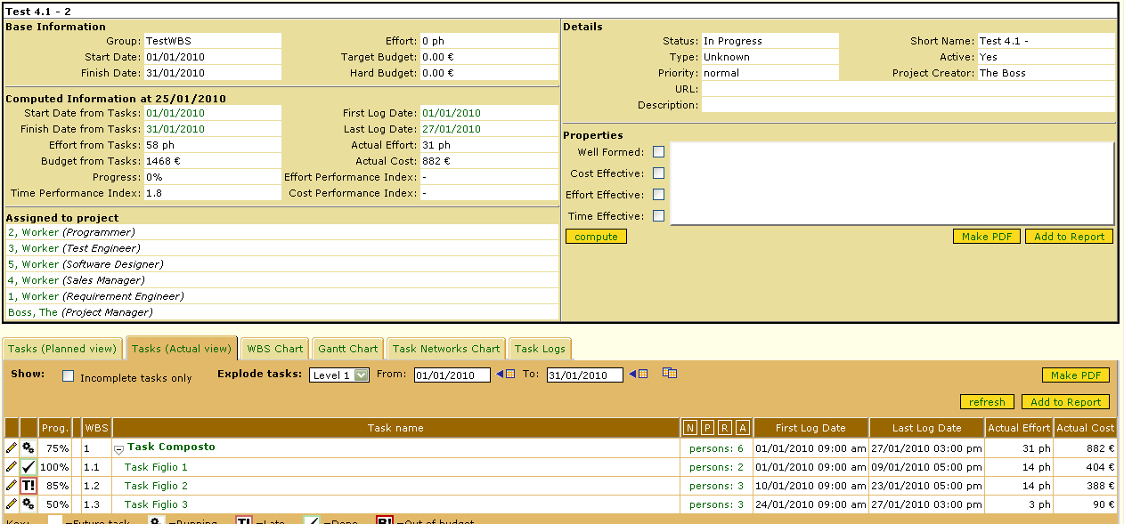
Figura 14: Input, actual view
Figura 15: Environment
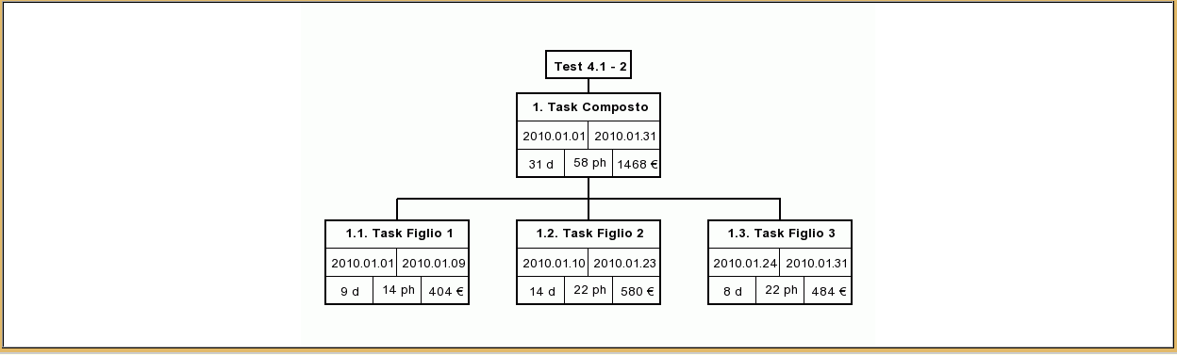
Figura 16: Output
Esempio 2:
Figura 17: Input, planned view
Figura 18: Input, actual view
Figura 19: Environment
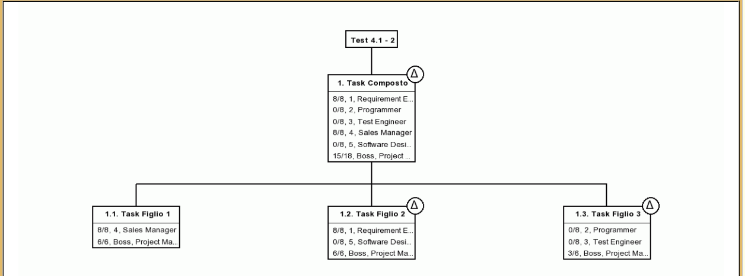
Figura 20: Output

- Task composto, collassando i sottotask.
Esempio 1:
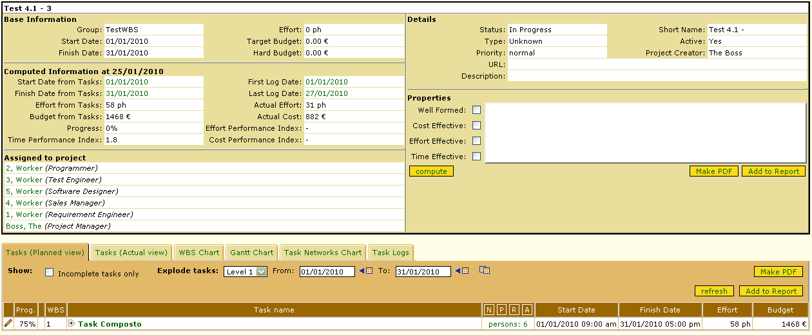
Figura 21: Input, planned view
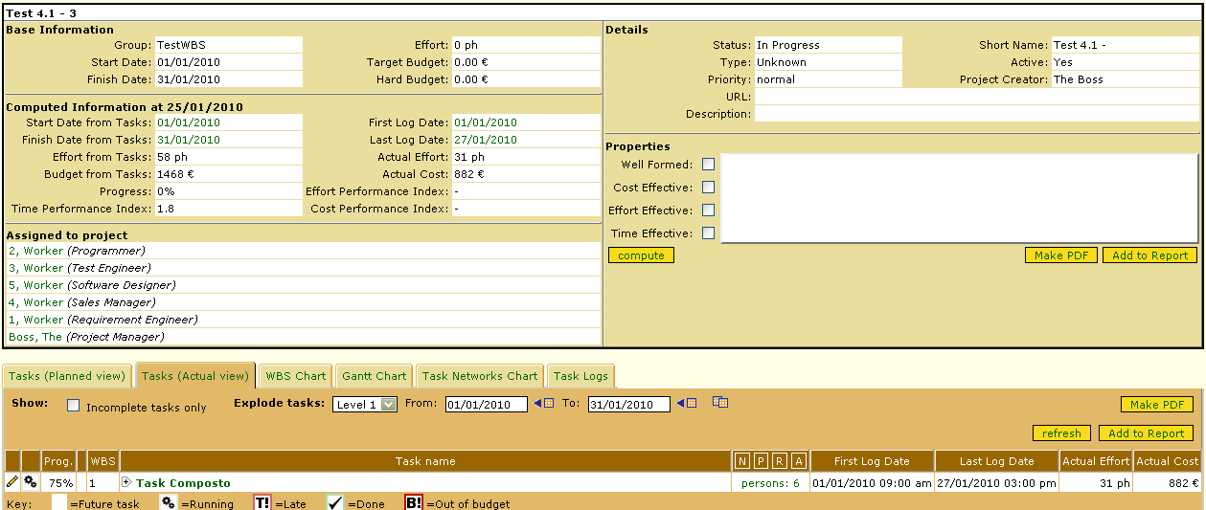
Figura 22: Input, actual view
Figura 23: Environment

Figura 24: Output
Esempio 2:
Figura 25: Input, planned view
Figura 26: Input, actual view
Figura 27: Environment

Figura 28: Output

- Varianti di task: coerenti, in anticipo, in ritardo, troppo costosi, non loggiati.
Esempio 1:
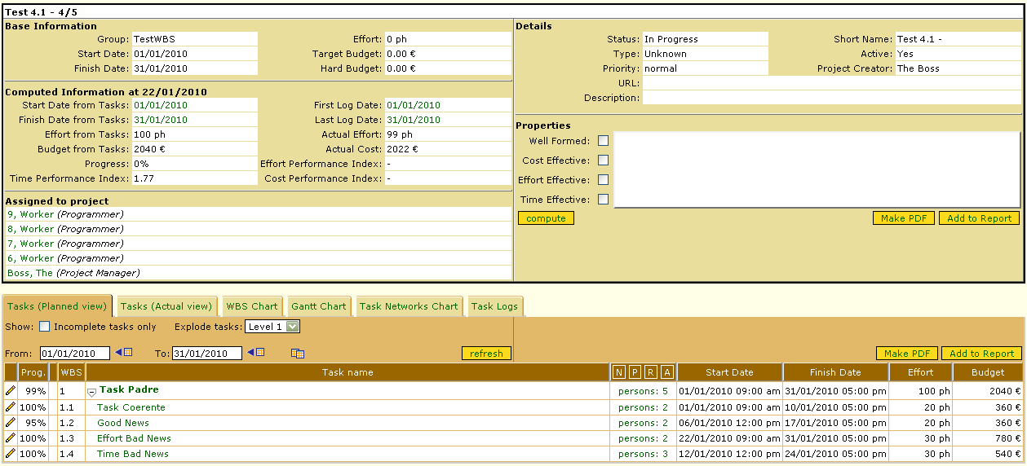
Figura 29: Input, planned view
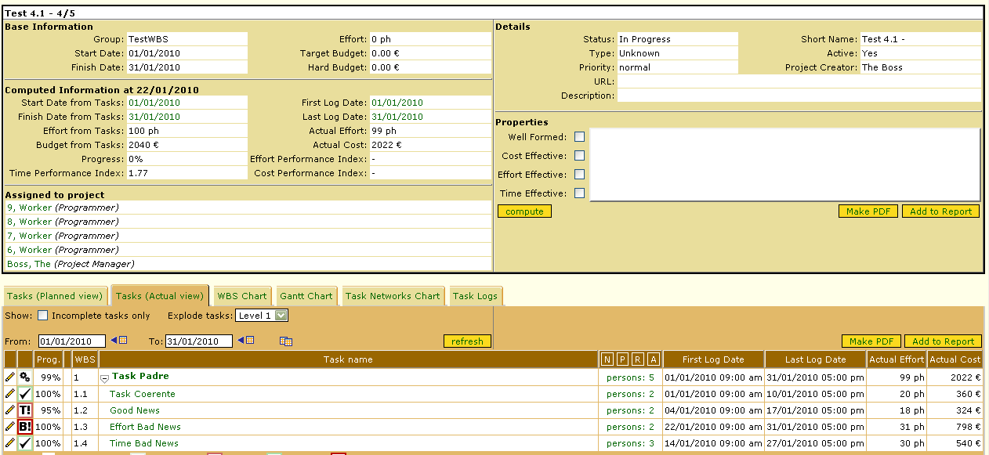
Figura 30: Input, actual view
Figura 31: Environment
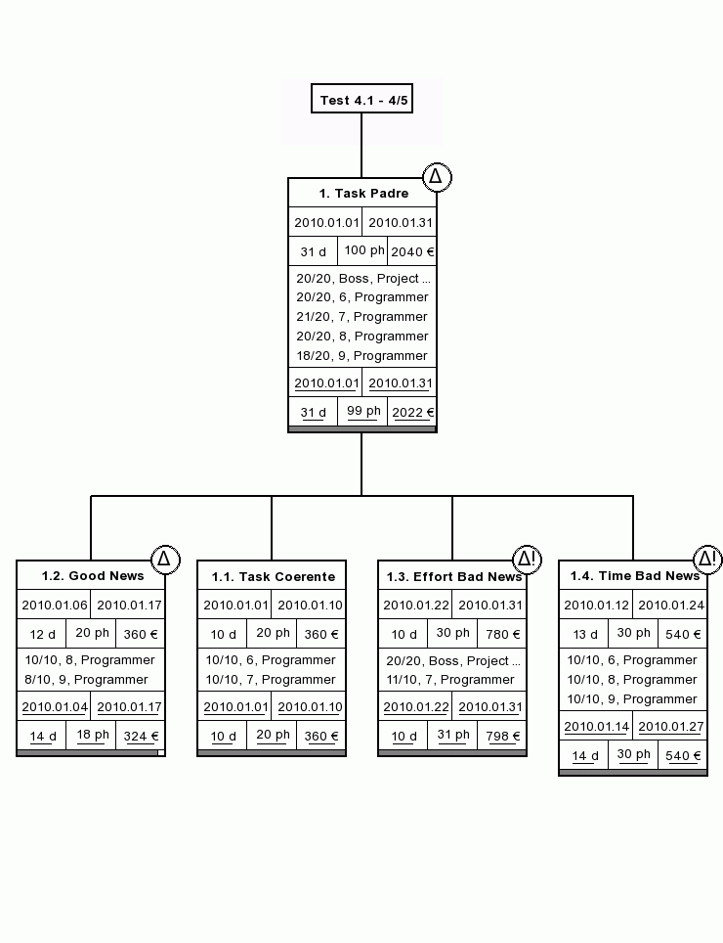
Figura 32: Output

Dimension of Task representation

